Data set stats
Dataset | Image count | Instances | Avg Inst per Image
Train | 158 | 4397 | 27.829
Test | 17 | 912 | 53.647
Validation | 12 | 700 | 58.333
Totals | 187 | 6009 | ---

Batch size results summary
Adam LR Comparison
Batch Size | Pre-Step |  | Post Step
Batch Size | 1e-5 | 5e-5 | 1e-5 | 5e-5
1 | 0.483 | 0.562 | 0.483 | 0.566
2 | 0.461 | 0.554 | 0.455 | 0.554
4 | 0.440 | 0.519 | 0.440 | 0.533
8 | 0.407 | 0.479 | 0.407 | 0.478
16 | 0.406 | 0.498 | 0.403 | 0.498

5e-5 Learning Rate Plots
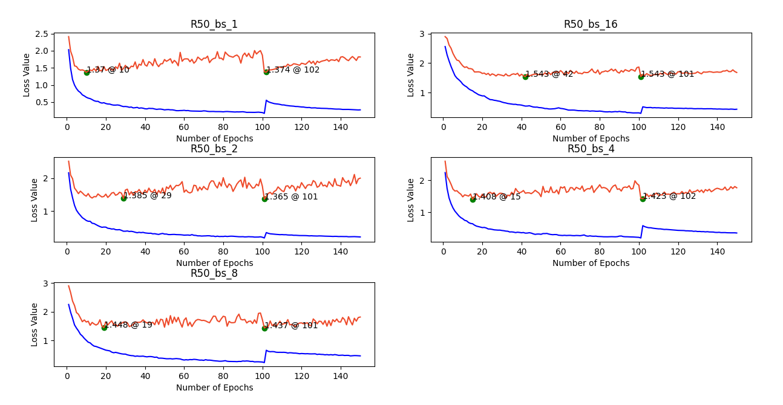

1e-5 Learning Rate Plots
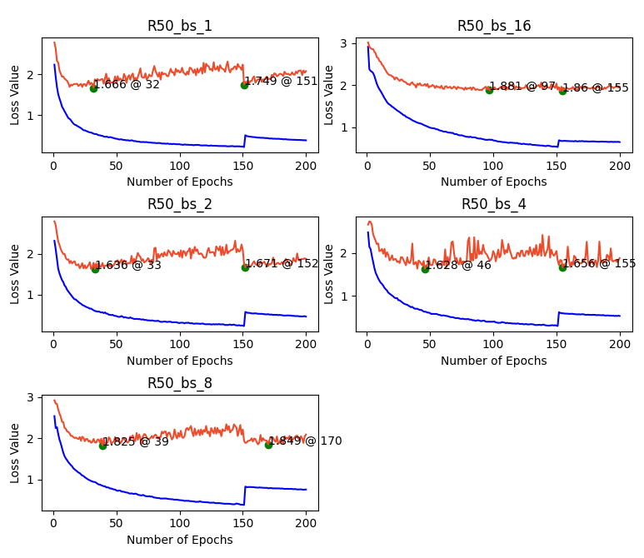

Adam vs SGD Comparison
Batch Size | Pre-Step |  | Post Step
Batch Size | SGD @ 5e-3 | Adam @ 5e-5 | SGD @ 5e-3 | Adam @ 5e-5
1 | 0.507 | 0.562 | 0.516 | 0.566
2 | 0.511 | 0.554 | 0.515 | 0.554
4 | 0.504 | 0.519 | 0.504 | 0.533
8 | 0.478 | 0.479 | 0.478 | 0.478
16 | 0.477 | 0.498 | 0.477 | 0.498

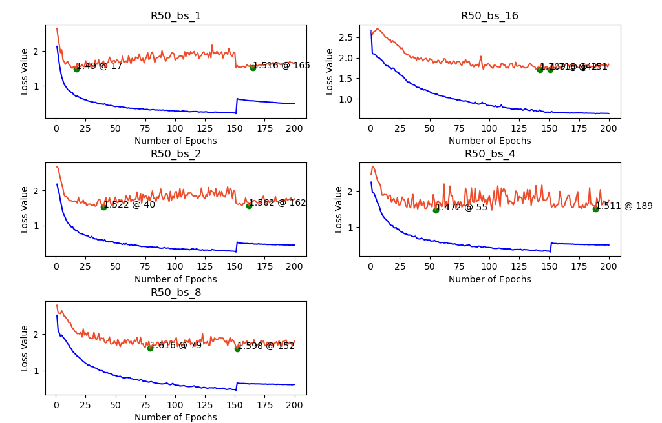
*for bs16 pre step 1.709@142 post step 1.718@151

Varied LR Results
Resnets 18 – 50 @ Adam LR: 1e-5 – 5e-5, bs @ 8

Batch Size | Pre-Step |  | Post Step
Batch Size | 1e-5 | 5e-5 | 1e-5 | 5e-5
R50 | 0.475 | 0.567 | 0.475 | 0.561
R34 | 0.460 | 0.544 | 0.469 | 0.547
R18 | 0.501 | 0.510 | 0.499 | 0.522

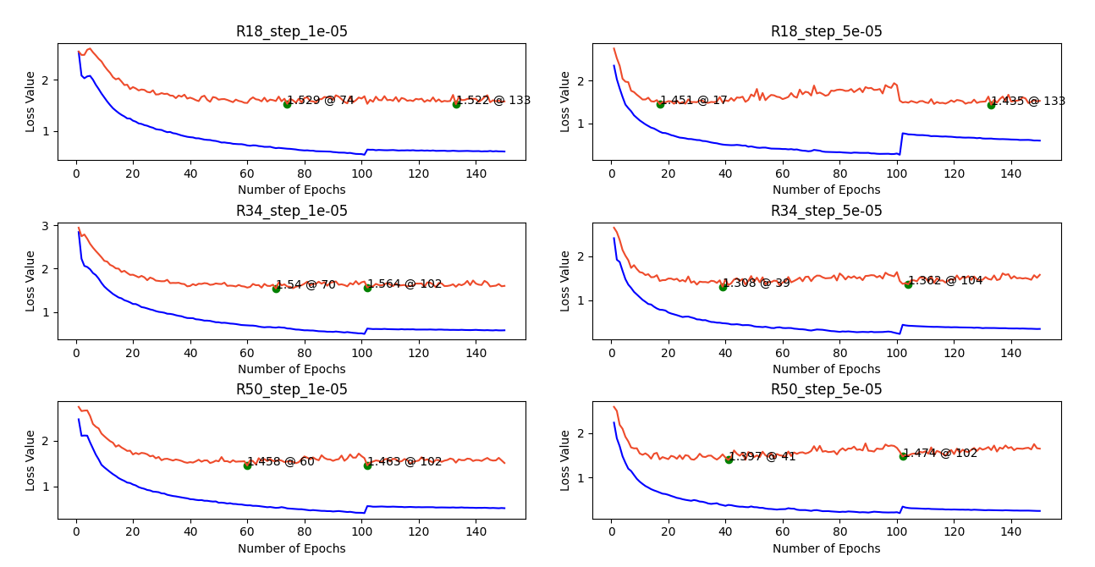

Resnets 18 – 50 @ SGD LR: 1e-3 – 5e-3, bs @ 2

Batch Size | Pre-Step |  | Post Step
Batch Size | 1e-3 | 5e-3 | 1e-3 | 5e-3
R50 | 0.566 | 0.584 | 0.574 | 0.577
R34 | 0.562 | --- | 0.558 | ---
R18 | 0.567 | --- | 0.565 | ---

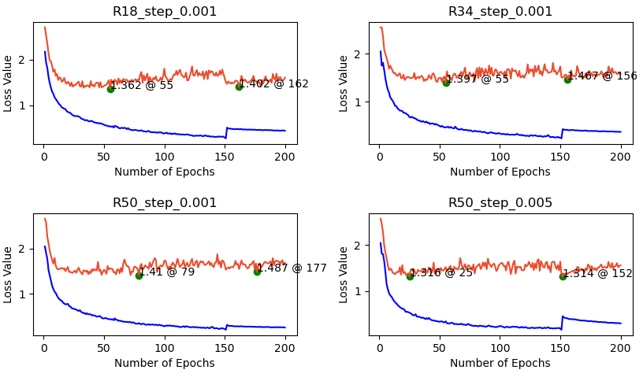

Resnets 50 @ Adem LR: 5e-3, bs @ 1

Batch Size | Pre-Step |  | Post Step
Batch Size | BS 1 | BS 8 | BS 1 | BS 8
R50 | 0.617 | 0.567 | 0.617 | 0.561

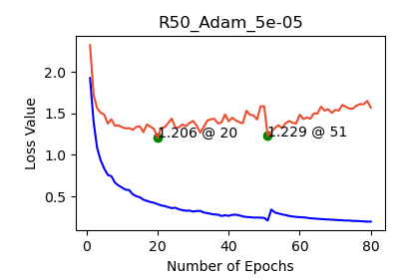

Batch Size Results Discussion
- Data is instance dence? Images have between ~8 and ~80 instances in them. A batch size of one does not mean the network has seen 1 instance between model wieght updata in the either the RPN or mask head

- Limited data? The model is overfitting better with higher batch size and the lack of data we have is becoming evident. The error or noise that is coming from smaller batch sizes may be helping and not hindering us in these approaches

- Could produce a dataset with greater amount of smaller less dense images by taking the current 1080x1920 images and producing 6 540x640 images to pass to the network. Dataset could increase from 158 to 948 images

- could place a callback to drop the learning rate quicker? This may be futile

